*Start a new Python project folder … do not reuse the previous workspace … As with any keyboard-driven console-like environment, developing muscle -memory for the common commands is also part of the learning curve.*

**For-loops**

* Suppose you want to iterate through the elements in the list below
* 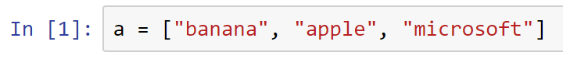
* Instead of printing the elements manually:
* 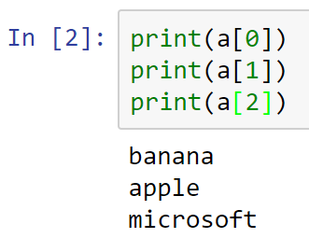
* You may use a loop to traverse through your list
* 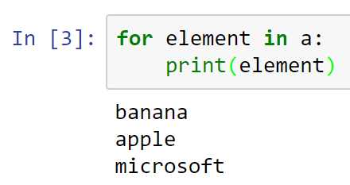
* You can have multiple statements in the for-block as long as you consistently use the same indentation spaces
* 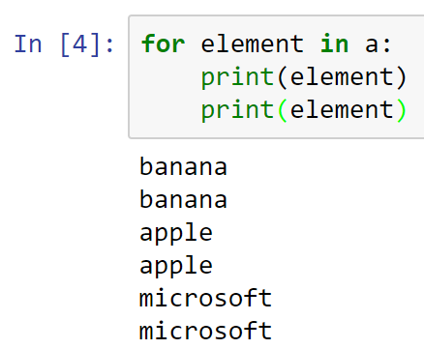
* The word element is a programmer-supplied name, so it can be anything you want
* Consider and run another example code below
* 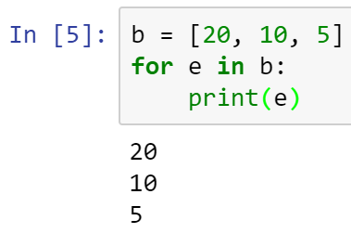
* To calculate the sum of all elements
* 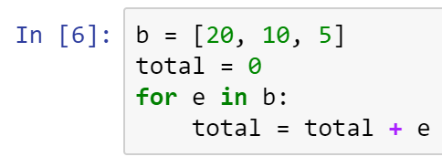
* Verify that total is correct
* 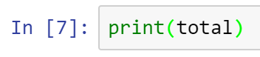
* What if you want to print the sum of a number series such as 1, 2, 3, 4, etc.
* *Python Power: You can use the ***range()*** function
* To create a range from 1 through 5, but excluding 5
* 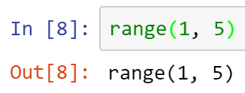
* Range technique is useful if you want to calculate the sum for say 1 to 100, etc.
* Try it out: calculate the sum from 1 to 100, but excluding the number 100.
* Place your answer here below:

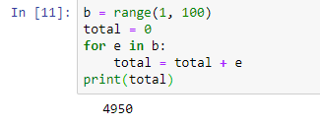

____________________________________________________________________________

* *Python Power: You can easily convert a range to a list.
* 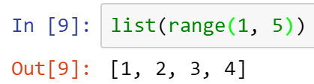
* The code above created a list structure with four elements: 1, 2, 3, 4
* You may refer to this new list from variable c
* 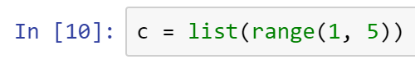
* To verify the content of list c
* 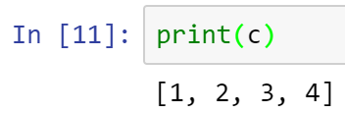
* You can use range in a for-loop
* 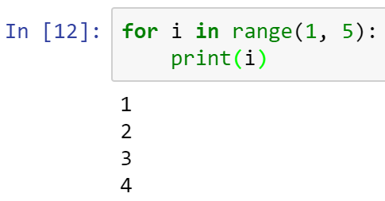
* Consider the list below
* 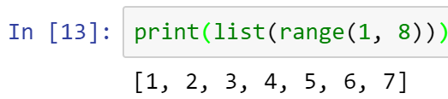
* Suppose you want to get the sum of only the multiples of 3?
* In the code above, the only multiple of 3 from this series is 3, and 6
* This can be achieved using the modulus operator (%)
* 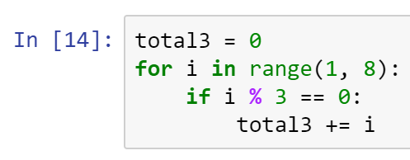
* Check that the output is correct
* 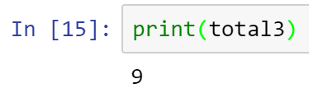
* Your turn: Compute the sum of all positive integers that are multiples of 3 and 5 that are less than 100.
* Place your answer here below:

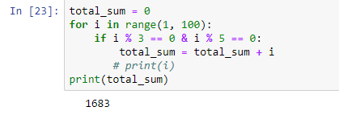

____________________________________________________________________________

* All submissions should be separate from other exercises and quests. Please do not lump all your answers into one document and re-using that same workspace to gain multiple points. Thanks.
* Place your name at the bottom of your code, download your Python program in html format, and submit your work in Canvas.